## GPU Debugger Tutorial

**Host Debugging**

**API-Level Debugging**

**Kernel Debugging**

**Additional Information**

### Host Debugging

Host Debugging is currently only available in the following configurations:  
1. Linux CodeXL Standalone application  
2. Windows CodeXL Visual Studio extension [native (C/C++) 32-bit target apps only]  
Other configurations support only API-Level debugging.

In the supported configurations, CodeXL allows Host debugging of any application, regardless of any APIs used.

The following features are supported:  
1. Host source code breakpoints  
2. Host stepping (step-in, step-over, step-out)  
3. Host break  
4. Host locals display  
5. Host expression evaluation (watch window)

CodeXL provides information directly from the system's native debugger, supporting any code and debug information that is available as those debuggers.

In the CodeXL standalone application, the debug controls are located in the Execution toolbar, next to the "Start Debugging" and "Stop Debugging" buttons. Setting source code breakpoints is as simple as opening a source file (Ctrl+O) and clicking the margins (F9). The Locals and Watch views are shared between Host Debugging and Kernel Debugging for a seamless experience.

In the CodeXL Visual Studio extension, Visual Studio's built-in views are used, providing a debugging experience as close to Visual Studio's built-in debug engines as possible.

### API-Level Debugging

CodeXL allows API-level debugging of any OpenCL and / or OpenGL based application, regardless of implementation version and underlying hardware.

API Debugging Basics

CodeXL API-level debugging is how CodeXL displays the CPU (client) side of your OpenCL or OpenGL application. This means CodeXL can suspend the debugged application at any OpenCL and OpenGL API function, display the call stack for these function calls, display API calls history and give many analysis options for debugging this part of the application.

To run the debugged application, press the Go button (F5).

Once the application is running, you can suspend it by adding an API breakpoint or by pressing the "break" button.

Once the application is suspended, you can use the API steps drop-down to choose between API Step (Ctrl + F10 - run to the next API function call), Draw Step (Ctrl + Shift + F10 - run to the next OpenGL draw call) and Frame Step (Ctrl + F11 - run to the next frame terminator API function call).

The CodeXL Explorer tree view is an invaluable view in CodeXL. When the debugged application is suspended (by a breakpoint, a step command, a break command, etc.), this view fills with the hierarchy of all OpenCL and OpenGL objects allocated by the debugged application. Each context or category can be expanded to show its contained objects, and the CodeXL Properties view updates with the details of the selected object. Double-clicking any of the objects usually shows the contents of the object in some form.

**CodeXL Explorer**

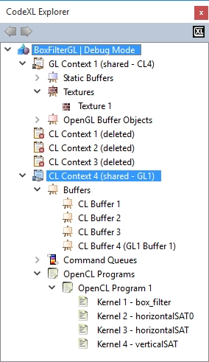

View Compute and Graphic Memory Consumption

All of the compute and graphic memory information collected by CodeXL is displayed in the Memory view. To open this view, right-click on the object in the object tree, and select the "Memory analysis" option of the object. This view lists all the allocated objects of a given type (for example, context 1's buffers), as well as information regarding their memory consumption depending on the kind of objects listed. The graph view shows a breakdown of all the graphic memory consumed by the items in the current category. To see the scenario that led to an object's creation, use the Creation Calls Stack view. If the debugged application has debug information, double-clicking on a line in the Creation Calls Stack view opens the location in the source file.

**Memory View**

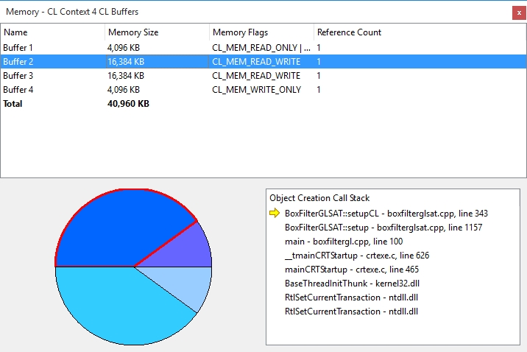

Find Unrecommended Function Calls

Open the Statistics view. In the "Function Calls Statistics" tab, you might see warning icons next to some of the function names. Click any of these functions to display an explanation of why is it unrecommended, and what alternative is available.

**Statistics View**

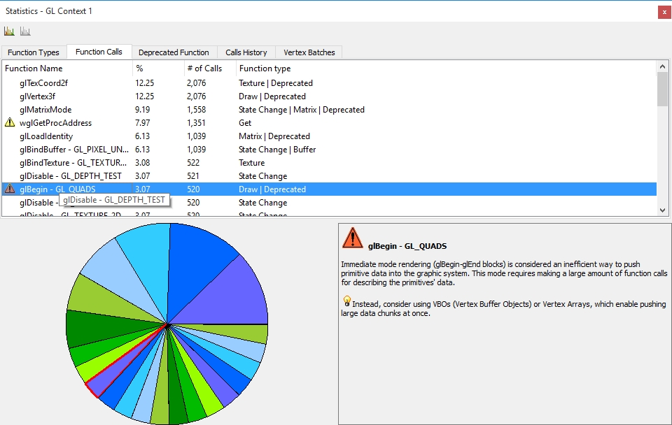

View Buffers, Images, and Textures Information and Data

Double-clicking the main branch for buffers, images, or textures in the CodeXL Explorer (such as "CL Context 1 Images" or "GL Context 3 VBOs") opens a thumbnail view for those objects, to give a quick overview. Clicking an object in this view or double-clicking it in the CodeXL Explorer opens an Object view for it in the main views area. This view has a Data view spreadsheet showing the raw object data where each cell in the spreadsheet shows the value of each pixel, and an Image view that visualizes the object. Clicking on a pixel samples it and keep its information in the "Selected Pixel" entry in the Information Panel on the right section of the view. Using the Images and Buffers toolbar, you can disable some or all the channels and zoom in and out on the image. You also can invert the image's colors, convert it to grayscale and rotate it. The Image Information panel on the right gives you controls over multi-imaged or multi-layered objects, such as 3D images, array textures, or mipmapped textures. Use the various sliders to change between the object elements.

**Objects View**

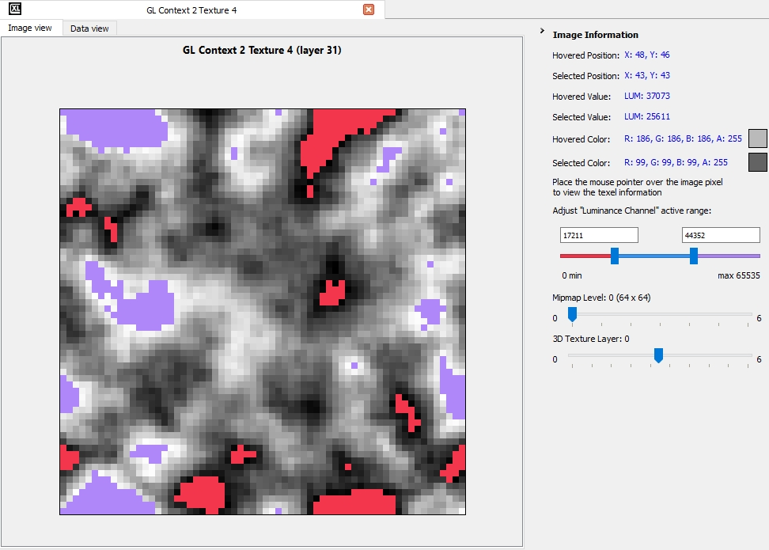

OpenCL buffers and OpenGL VBOs do not have the context of pixels, coordinates, and channels; thus, they are not visualized by the image view. Since they contain raw byte data, they even have no type or format information built-in into them. Instead, the Information panel has a combo-box letting you choose from the available data types and formats for use in their respective APIs.

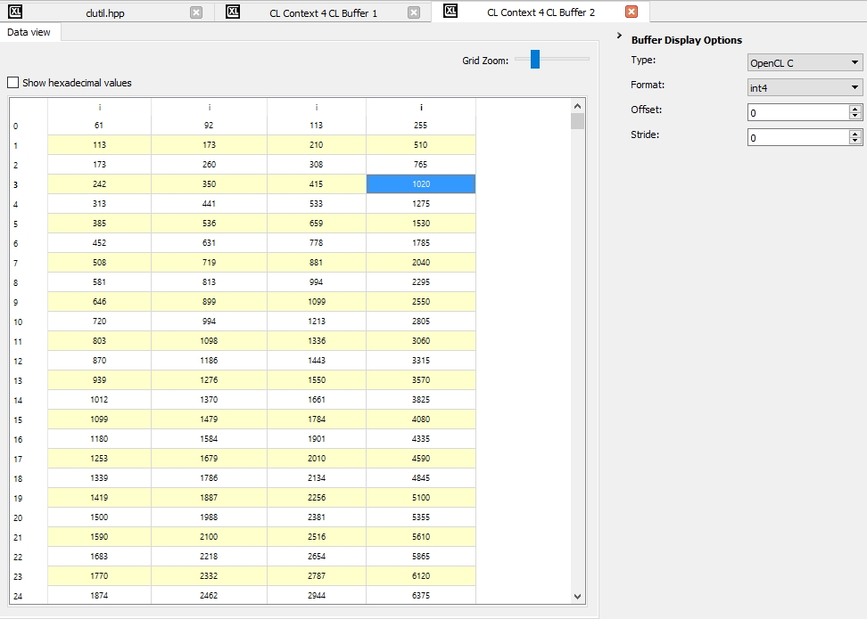

View OpenCL Program and OpenGL Shader Source Code

To view an OpenCL program or OpenGL shader's source code, double-click it in the CodeXL Explorer. If you are using *.cl files for OpenCL program source, adding the directory as the kernel source files folder in the Debug Settings dialog lets CodeXL to identify the source. This means you can set breakpoints inside the program before it was created and built at runtime, and you can persist breakpoints between debug sessions. Source viewing, of course, only applies to objects compiled at run time, and does not work with objects created with binaries. Double-clicking a kernel highlights the kernel function inside the program source. Applications that load program or shader source from strings or generate it at run time, have the sources saved to temporary files. Use the "File > Save As..." option to keep these files for comparison or analysis.

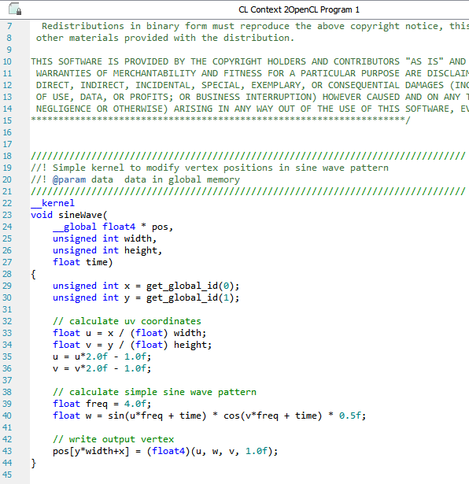

View OpenGL Program Pipeline and Sampler Objects

To view an OpenGL Program Pipeline or Sampler object, click on the object’s node in the CodeXL Explorer. This will display the object’s current state in the CodeXL Properties view. The state of Program Pipelines may contain references to OpenGL Shaders. These references will be displayed in the CodeXL Properties view as links. To view an OpenGL Shader’s source code, just click on the link. Here is a snapshot of the CodeXL Properties view after clicking on a Program Pipeline object.

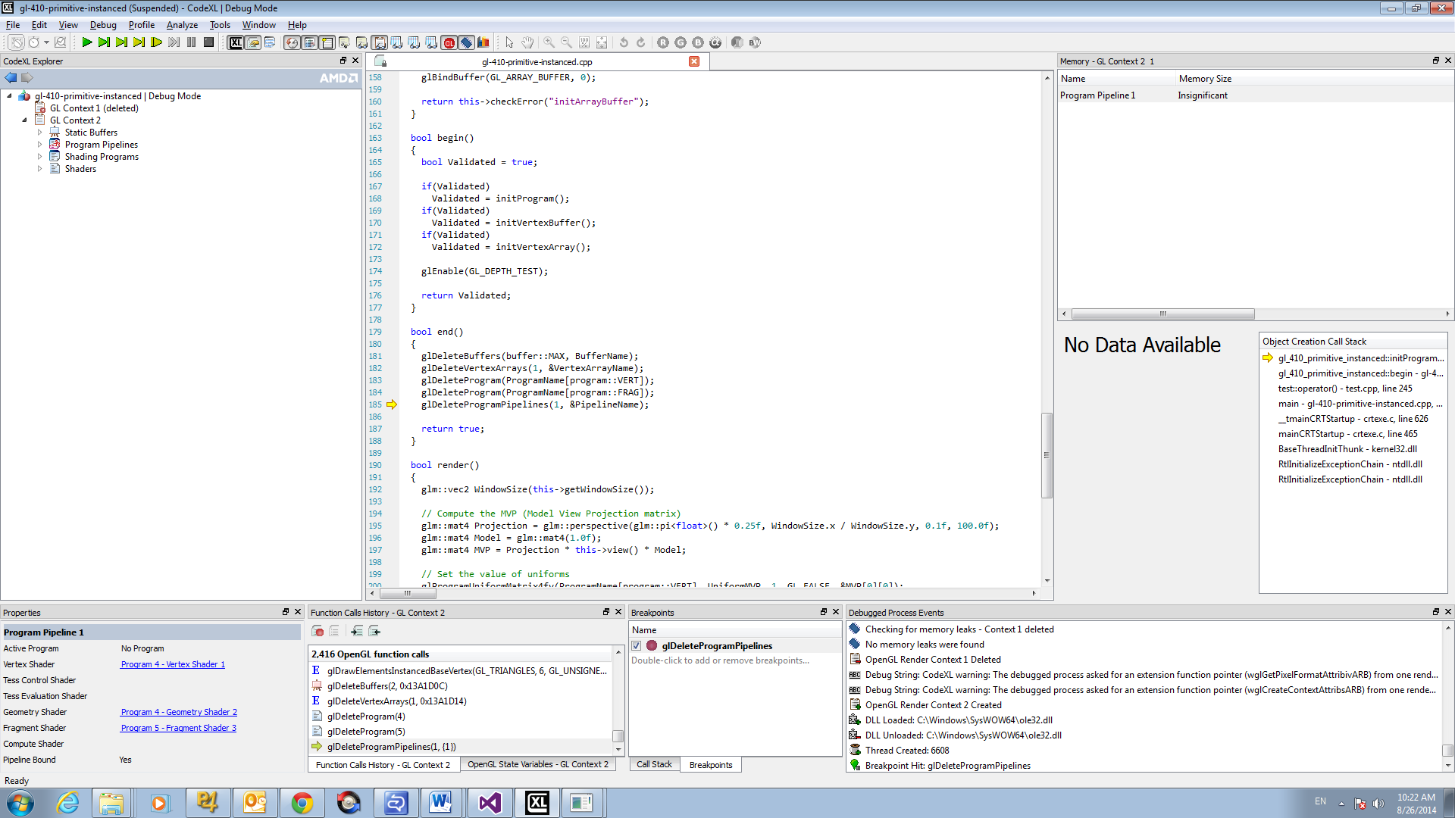

Here is a snapshot of the CodeXL Properties view displaying the state of an OpenGL Sampler object. Note that the “Bound to the following Texture Units” field may contain more than one texture (in a comma separated list between the curly brackets).

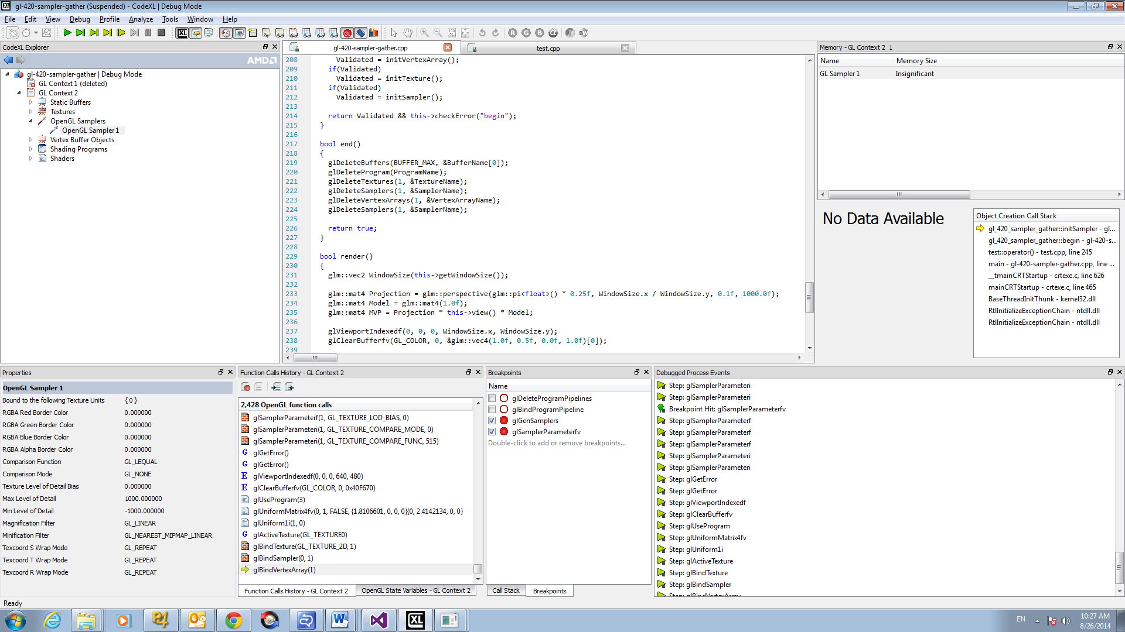

Work with API Function Breakpoints

Any CodeXL-supported OpenCL or OpenGL function can be set as a breakpoint in the Breakpoints dialog (Alt+Shift+B). The API Functions list contains all the supported functions. The Active Breakpoints list contains all the currently selected breakpoints. Each selected breakpoint has a checkbox next to it, representing whether the breakpoint is currently enabled. Disabling breakpoints instead of removing them saves the time of finding the function each time you want to enable the breakpoint. To add a function to the breakpoints list, select it in the API functions list and press Add or double-click it. To remove a breakpoint, select it in the breakpoints list and press Remove or double click it. Using breakpoints can help you see the exact API status before the function is called, also allowing a comparison of the status before and after the function call (by pressing the Step Over button (F10) after the breakpoint hit). You also can use breakpoints to find where in your code each function is called, by looking at the Call Stack view after the breakpoint is hit. if you have debug information for the stack item, you can double-click it to see the exact location in the MDI source view.

**Break point Dialog**

### Kernel Debugging

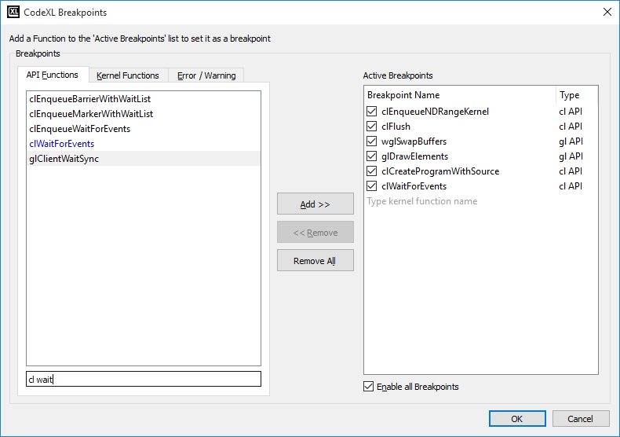

View Statistical Information About API Usage

Open the CodeXL Statistics view. The best way to overview your application's API usage is to collect the statistics for a few complete frames. Let your application run for a few frames, then suspend it by pressing Break All (F6). If you are using frame terminators, press the Step Out button (Shift+F11) to advance to the end of the current frame. Alternatively, set a breakpoint on a frame terminator, and Continue (F5) past it a few times to collect enough information. This gives you the clearest statistical information about your API usage. To change between the statistics for different OpenCL and OpenGL contexts, choose them in the CodeXL Explorer.

The Function Types Statistics tab shows your OpenCL and OpenGL usage by function types. The percentages here do not always add up to 100% because an API function can belong to many or none of the categories. In the Function Calls Statistics tab, you can see details of specific functions, including the function types each function belongs to. In the Vertex Batch Statistics tab, you can see details of your application's vertex batches by size, giving an overview of the vertex sizes and occurrence, as well as the total number of vertices drawn with each batch size.

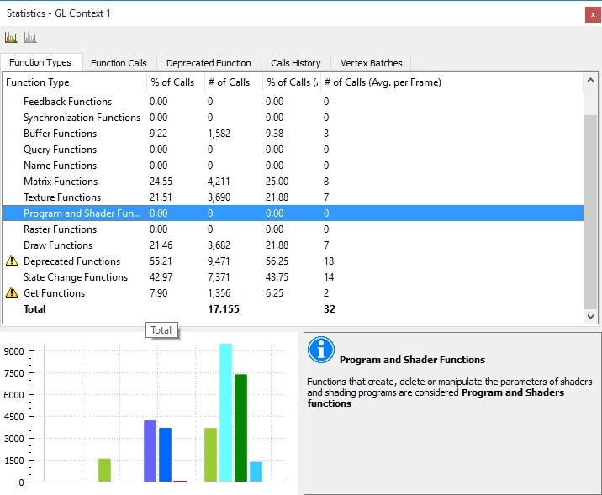

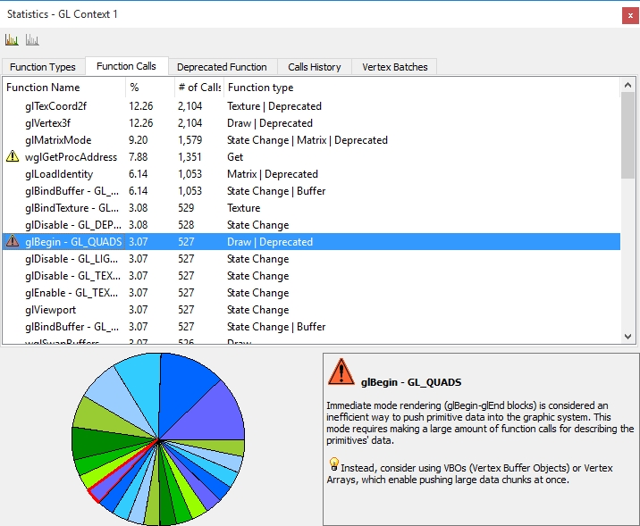

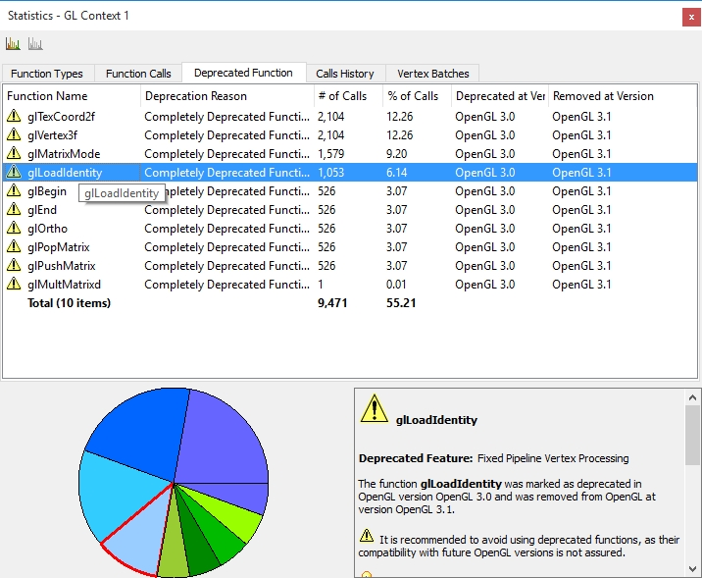

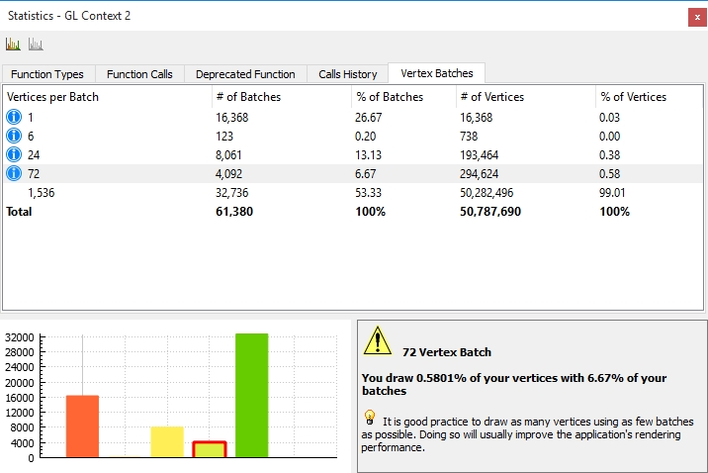

Kernel Debugging

On AMD GPU hardware ,CodeXL allows debugging OpenCL kernels in real time on AMD GPU hardware, with only a single machine and single device, and with hardware results.

Enter Kernel Debugging

There are three ways to enter kernel debugging:

* After starting debugging and suspending the process (with Break / F6 or an API function breakpoint), use the Step command or an API function breakpoint to get to an API call of clEnqueueNDRangeKernel or clEnqueueTask. Then, press Step Into (F11) to start debugging the kernel.
* Add the kernel function name as a kernel function breakpoint in the breakpoints dialog (Alt+Shift+B), by switching to the Kernel Functions tab or by manually typing in the kernel name in the Active Breakpoints list. When a kernel matching the function name starts executing, the debugged process stops at the kernel’s beginning.
* From the CodeXL Explorer view, open the OpenCL program, and set a breakpoint inside the code. The application stops inside the kernel when it hits the breakpoint.

Kernel Debugging Control

While in kernel debugging, press step over (F10) to step to the next line in the same scope, step in (F11) to enter functions called inside the kernel, or step out (Shift+F11) to leave the current function or kernel.

You can also set kernel source breakpoints by selecting a line in the kernel and pressing Add Breakpoint (F9), or clicking in the margin next to the line. Press Continue (F5) to run up to the breakpoint. You can also set a breakpoint inside a function to enter that function (as with stepping in).

Focus On a Specific Work-Item

CodeXL's Current Work-Item toolbar lets you select a single work-item to focus on in CodeXL. If the toolbar is not open, right-click in the toolbars area, and select it from the dropdown menu. The combo-boxes for X, Y, and Z coordinates are enabled and offer values depending on the currently debugged kernel's N-Dimensional global work size. Selecting a work-item has the following effects:

* The locals and Watch views display variable values for this work-item.
* When stepping through kernel debugging, "if" or "else" clauses not entered by the selected work-item are skipped.
* The work-item is selected in the MultiWatch views.

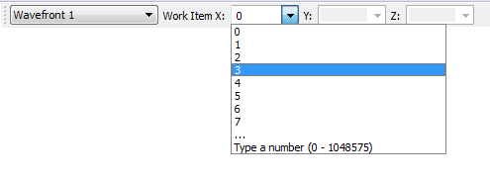

Inspect Variable Values

Use the Local and Watch views to inspect variable values. The Locals view displays all variables that are currently in-scope. Use the Watch view to dereference pointers (*p) or access array members (a[150]).

The values shown in all these views are the at the current work-item, as selected by the current work-item toolbar.

Compare Variable Values Across Work-Items and Work-Groups

Use CodeXL Multi-Watch views to compare the values of variables across various work-items and work-groups. To open a Multi-Watch view, select it from the Views toolbar or menu, or right-click a variable and select "OpenCL Multi-Watch...". The view's variable selection combo-box offers all variables that can be viewed (similar to the Locals view list). Select a variable to view its values. The main view displays a spreadsheet or graphical representation of the values along a sliding scale ranging from the lowest value to the highest. Move the pointers in the Active Range slider to quickly highlight values outside a given range.

In Data (spreadsheet) view, the variable values are placed into cells according to their work-item coordinates. Work-groups are alternately colored white and gray, letting you easily see the edge of a work-group.

In Image view, variables inside the range are colored on a gradient scale from black (lowest) to white (highest). Values below the range are red; values above the range are purple; work-items that are out of scope are yellow.

For three-dimensional work sizes, use the Z coordinate slider to navigate between the various XY planes in the global work.

The "hovered" controls display the location, value, and color for the mouse cursor's location. Click the view to set the current values to the "selected" control for an easy comparison against a single work-item. This also centers the Data view on the selected item.

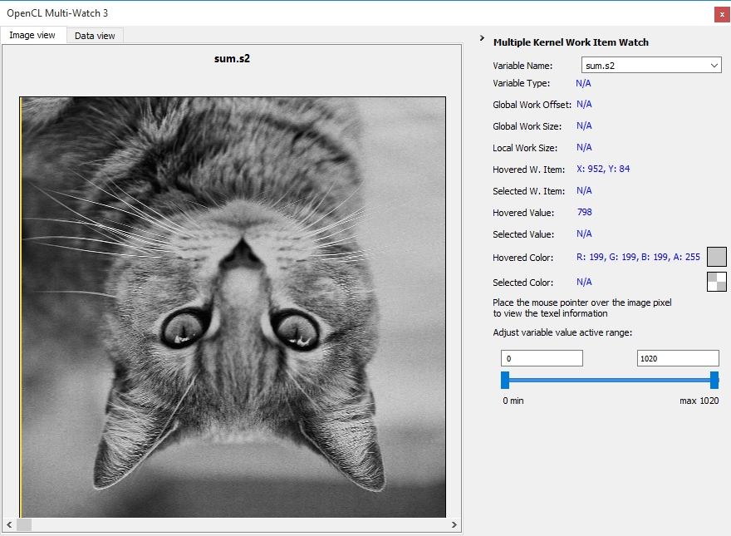

### Keyboard Shortcuts

|  |  |
| --- | --- |
| **Views and Dialogs** | |
| New Project wizard | Ctrl+N |
| Debug Settings dialog | Ctrl+O |
| Breakpoints dialog | Alt+Shift+B |
| **Common Debugging** | |
| Go (Start / Continue Debugging) | F5 |
| Stop Debugging | Shift+F5 |
| **API-Level Debugging** | |
| Break at next API function call | F6 |
| Step to next API function call | F10 |
| Step into kernel debugging | F11 |
| Step to next frame terminator | Ctrl+F11 |
| **Kernel Debugging** | |
| Step Over | F10 |
| Step Into function | F11 |
| Step Out of function / kernel | Shift+F11 |
| Set / remove breakpoint at kernel source | F9 |